
Cloud Computing (BCSE408L)
SmartSpend – A Serverless Personal Expense Tracker

Raghav Sanoria – 23BCE0877
Madhav Sah – 23BCE0868
School of Computer Science and Engineering (SCOPE)

Table of Contents
Revision History
- Abstract
- Proposed Work
  - Problem Statement
  - Objectives
  - System Architecture
  - Modules
  - Technology Stack
  - How It Works (End to End)
  - Expected Outcomes
  - Timeline
- References

1. Abstract
Keeping track of daily expenses is something most people struggle with. Either we forget to note things down, or we end up entering wrong amounts, or we just stop doing it after a week. The apps that exist today still require a lot of manual work — you have to type everything in yourself.
In this project, we are building an expense tracker called SmartSpend that runs entirely on AWS cloud services. The idea is simple — you can either upload a photo of your receipt or type in the expense manually through a web page. If you upload a receipt, the system uses Amazon Textract to read the image and pull out the merchant name, date, and total amount on its own. You don't have to type anything.
Once the expense is captured, a machine learning model running inside AWS Lambda automatically puts it into a category like Food, Transport, Shopping, etc. If the system notices that you've spent way more than your usual amount in any category, it sends you an email alert using Amazon SNS so you know something is off.
The whole backend is serverless — we are using AWS Lambda for processing, API Gateway for handling requests, S3 for storing receipt images, and RDS for saving all the expense data. The frontend is a simple web page hosted on S3 itself. The best part is that everything we are using falls under the AWS Free Tier, so the entire project costs nothing to run.
Keywords: Serverless, AWS Lambda, Amazon Textract, Expense Tracking, Machine Learning, S3, RDS, Cloud Computing

2. Proposed Work

2.1 Problem Statement

Most people don't track their expenses consistently because it takes too much effort. You have to open an app, type the amount, select a category, enter the date — it feels like a chore. And even if someone does it regularly, there is no way to catch unusual spending unless you sit down and go through everything manually. We want to solve both of these problems using cloud services and ML.

2.2 Objectives
- Build a fully serverless expense tracking application on AWS with zero infrastructure management.
- Let users upload receipt photos and automatically extract expense details using Amazon Textract (OCR).
- Provide a manual entry option as a fallback when receipts are not available.
- Automatically categorize each expense using a trained Scikit-learn classification model.
- Detect abnormal spending and notify the user through email alerts via Amazon SNS.
- Show a simple dashboard with monthly totals and category-wise breakdowns.
- Keep the entire project within the AWS Free Tier so there is no cost involved.

2.3 System Architecture

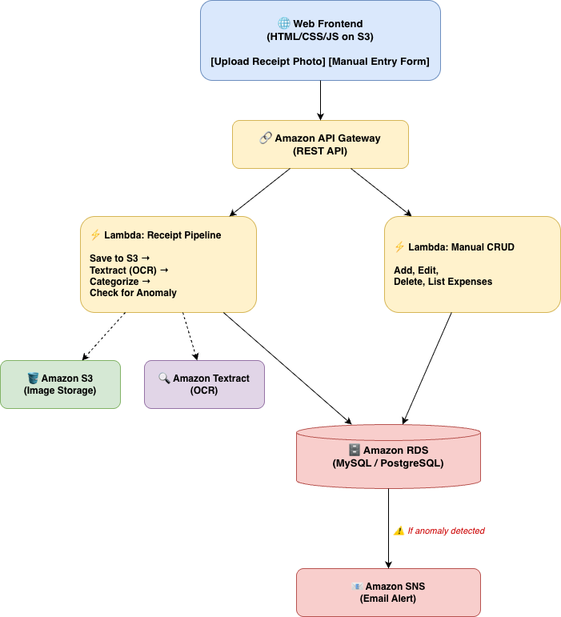

2.4 Modules
- Module 1 – Web Frontend A basic web page where the user can either upload a receipt image or fill in the expense details manually. It also shows a dashboard with all the logged expenses, monthly totals, and a simple pie chart for category-wise spending. We are planning to host this directly on S3 as a static website.
- Module 2 – API Layer All communication between the frontend and backend goes through Amazon API Gateway. We will set up REST endpoints for uploading receipts, adding manual entries, fetching expense lists, and so on.
- Module 3 – Receipt Upload and Storage When a user uploads a receipt image, the Lambda function saves it to an S3 bucket. This way we always have the original receipt stored in the cloud and can refer back to it.
- Module 4 – OCR and Data Extraction (ML) Once the receipt is stored in S3, the same Lambda function calls Amazon Textract's AnalyzeExpense API. Textract reads the receipt image and returns the merchant name, date, and total amount. We parse this response and use the extracted data as the expense entry. This is the main ML component — Textract uses pre-trained deep learning models internally to understand document layouts.
- Module 5 – Expense Categorization (ML) After extracting the data, we pass the merchant name through a Scikit-learn classification model (something like Naive Bayes or Random Forest). This model is trained beforehand on a small dataset of merchant-to-category mappings — for example, "Swiggy" maps to Food, "Uber" maps to Transport, "Amazon" maps to Shopping. The trained model file is bundled inside the Lambda deployment package itself, so there is no extra cost.
- Module 6 – Anomaly Detection and Alerts Every time an expense is logged, the system checks if the amount is significantly higher than the user's average for that category. If it crosses a threshold (say 3 times the average), a Lambda function publishes a message to Amazon SNS, which sends an email notification to the user saying something like "Unusual spending detected in Food category – ₹1200 against your average of ₹200."
- Module 7 – Database Operations All expense records (merchant, amount, date, category, receipt URL) are stored in Amazon RDS. The Lambda functions handle all the basic CRUD operations — create, read, update, delete.
- Module 8 – Dashboard and Analytics The frontend pulls data from the API and displays it using Chart.js. We are planning to show a table of recent expenses, monthly spending totals, and a pie chart breaking down spending by category. Nothing fancy, but enough to be useful.

2.5 Technology Stack
Layer | What We Are Using
Frontend | HTML, CSS, JavaScript, Chart.js
Hosting | Amazon S3 (static website hosting)
Backend | AWS Lambda (Python 3.x)
API | Amazon API Gateway (REST)
Database | Amazon RDS (MySQL or PostgreSQL)
File Storage | Amazon S3
OCR/ML | Amazon Textract
Categorisation/ML | Scikit-learn (inside Lambda)
Alerts | Amazon SNS

2.6 How It Works (End to End)
- User opens the web page and either uploads a receipt photo or fills in the manual entry form.
- The request hits API Gateway, which routes it to the appropriate Lambda function.
- If it's a receipt upload — Lambda saves the image to S3, calls Textract to extract the details, runs the categorization model, checks for anomalies, and saves everything to RDS.
- If it's a manual entry — Lambda directly saves the data to RDS after running categorization and anomaly check.
- If an anomaly is found, SNS sends an email to the user.
- The dashboard fetches all expenses from the API and displays them with charts.

2.7 Expected Outcomes
- A working serverless expense tracker deployed on AWS.
- Receipt images processed automatically with reasonable OCR accuracy using Textract.
- Expenses auto-categorized into at least 5 categories (Food, Transport, Shopping, Utilities, Entertainment).
- Email alerts triggered when unusual spending is detected.
- A functional web dashboard showing expense history and spending patterns.
- Total AWS cost: ₹0 (everything within free tier).

2.8 Timeline
Week | What We Plan To Do
Week 1 | Set up AWS account, create S3 bucket, RDS instance, API Gateway and billing alarm. Design database tables.
Week 2 | Build Lambda functions for receipt upload (S3 + Textract pipeline) and manual CRUD operations.
Week 3 | Train the categorization model locally and deploy it inside Lambda. Set up anomaly detection logic and SNS alerts.
Week 4 | Build the web frontend — upload page, manual entry form, dashboard with Chart.js.
Week 5 | End-to-end testing, bug fixes, documentation and demo preparation.

3. References
- Amazon Web Services, "AWS Lambda – Serverless Compute," https://aws.amazon.com/lambda/
- Amazon Web Services, "Amazon Textract – Intelligent Document Processing," https://docs.aws.amazon.com/textract/latest/dg/analyzing-examples.html
- Amazon Web Services, "Amazon S3 – Cloud Object Storage," https://aws.amazon.com/s3/
- Amazon Web Services, "Amazon RDS – Managed Relational Database Service," https://aws.amazon.com/rds/
- Amazon Web Services, "Amazon API Gateway – Create, Maintain, and Secure APIs," https://aws.amazon.com/api-gateway/
- Amazon Web Services, "Amazon SNS – Pub/Sub Messaging and Mobile Notifications," https://aws.amazon.com/sns/
- aws-samples, "Amazon Textract Analyze Expense Processing Pipeline," GitHub Repository, https://github.com/aws-samples/amazon-textract-analyze-expense-processing-pipeline
- B. Arrieta, "Build a Serverless Workflow: AWS Lambda + Textract (Sync & Async with SNS/SQS) – Step by Step," DEV Community, 2025.
- F. Pedregosa et al., "Scikit-learn: Machine Learning in Python," Journal of Machine Learning Research, vol. 12, pp. 2825–2830, 2011.
- Amazon Web Services, "AWS Free Tier," https://aws.amazon.com/free/

